SEO AUDIT REPORT

FreeInternships.in
Website: www.freeinternships.in
Audit Type: Comprehensive SEO Audit
Audit Period: 2026
Prepared for: FreeInternships.in
Prepared by: Jenisha Amalapushpam A
Table of Contents
- Executive Summary
- SEO Findings & Scorecard
- Detailed SEO Recommendations & Action Plan
- 30/60/90-Day SEO Action Plan
- Final Conclusion & Future SEO Strategy
- Day 1 – Research & Planning
- Day 2 – Technical SEO Analysis
- Day 3 – On-Page SEO Analysis
- Day 4 – Off-Page SEO Analysis
10.Day 5 – Competitor Analysis
11.Screenshots & Evidence

Executive Summary
Website Audited: FreeInternships.in
Website: www.freeinternships.in
Audit Type: Comprehensive SEO Audit
Audit Period: 2026
Objective:
The objective of this SEO audit is to evaluate the technical SEO, on-page SEO, off-page SEO and competitive position of FreeInternships.in and identify opportunities to improve search visibility, website performance, user experience and organic traffic.
Overall Finding:
FreeInternships.in has a good foundation for SEO, with relevant internship content, a clear website purpose, proper heading structure, descriptive image ALT text, an accessible XML sitemap and an existing backlink profile. However, improvements are required in website performance, backlink authority, broken links, metadata optimization and competitive SEO.
Key Findings
Technical SEO
- Desktop Core Web Vitals failed mainly because of a high CLS value.
- Mobile Core Web Vitals passed, but the overall mobile performance score was low.
- XML sitemap is available.
- Four broken links were identified during a partial scan of 671 pages.
- Google Search Console access was not available during the audit.
On-Page SEO
- Homepage H1 and heading structure are good.
- Homepage content is relevant to students and internship searches.
- Image ALT text was descriptive in the reviewed source.
- Homepage title can be shortened and improved.
Off-Page SEO
- Ahrefs reported 691 backlinks from 118 linking websites.
- Domain Rating was 7.
- Moz-based checking showed DA 10/100 and 45 linking domains.
- The backlink profile and domain authority need improvement.
Social Media
- LinkedIn and YouTube presence was identified on the Contact Us page.
Competitive SEO
- Major competitors include AICTE Internship Portal, Skill India Digital Hub, Upskill Campus and Thiranex.
- Competitors have strong advantages in government credibility, internship listings, filtering, career support and/or free internship offerings.
- FreeInternships.in can differentiate itself through free practical projects, certificates, student-focused content and better SEO targeting.
Overall Conclusion
FreeInternships.in has a strong opportunity to improve its organic search visibility. Priority should be given to technical performance, fixing broken links, improving website authority, optimizing metadata, creating targeted content and building high-quality backlinks.
Overall SEO Status: Good Foundation – Needs Improvement

SEO Findings & Scorecard
The following scorecard summarizes the major SEO areas identified during the audit of FreeInternships.in.
SEO Area | Score | Status | Key Finding
Technical SEO | 65/100 | Needs Improvement ⚠️ | Desktop Core Web Vitals failed, mobile performance score was low, and 4 broken links were identified during a partial scan.
On-Page SEO | 78/100 | Good ✅ | Heading structure, content and image ALT text were good, but the homepage title can be improved.
Content & Keywords | 80/100 | Good ✅ | Relevant internship-related keywords and useful student-focused content are present.
Off-Page SEO | 45/100 | Needs Improvement ⚠️ | Domain Rating and Domain Authority are relatively low, so website authority needs improvement.
Social Media | 70/100 | Good with Improvement ✅ | LinkedIn and YouTube presence was identified, but stronger social promotion can improve visibility.
Competitor SEO | 65/100 | Needs Improvement ⚠️ | Competitors have strong advantages in credibility, listings, filtering, career support and free internship offerings.
Overall SEO Assessment
Overall Score: 67/100
Overall Status: Good Foundation – Needs Improvement ⚠️
Main Strengths
- Clear focus on free internships for students.
- Relevant internship-related content and keywords.
- Good H1 and heading structure.
- XML sitemap is available.
- Descriptive ALT text was found in the reviewed images.
- Existing backlink profile and social media presence.
Main Issues
- Desktop Core Web Vitals need improvement.
- Mobile performance score needs improvement.
- Broken links should be fixed.
- Homepage title should be shortened and optimized.
- Domain authority and backlink quality need improvement.
- Competitors have stronger authority and broader visibility.
Priority
The most important improvements should be:
- Improve website speed and Core Web Vitals.
- Fix all identified broken links.
- Build high-quality and relevant backlinks.
- Improve homepage title and other important metadata.
- Create more targeted internship content.
- Strengthen social media promotion and brand mentions.
- Improve SEO targeting for specific student groups and internship domains.
Note: The scorecard scores are qualitative audit assessments based on the findings collected during this project. They are not official Google ranking scores.

Detailed SEO Recommendations & Action Plan
Based on the SEO audit findings, the following recommendations can help FreeInternships.in improve its search visibility, website performance, user experience and organic traffic.
A. Technical SEO Recommendations
- Improve Page Speed
  - Optimize large images and use modern image formats such as WebP.
  - Reduce unnecessary JavaScript and CSS.
  - Minimize unused website resources.
  - Improve server response time.
- Improve Core Web Vitals
  - Desktop Core Web Vitals should be improved, especially CLS.
  - Reserve fixed space for images, banners and dynamic elements to prevent layout shifts.
  - Continue monitoring LCP, INP and CLS.
- Fix Broken Links
  - Fix or redirect the 4 broken links identified during the partial scan.
  - Check important internal links regularly.
  - Remove links that point to permanently unavailable pages.
- Maintain XML Sitemap
  - Keep the XML sitemap updated.
  - Include important, canonical and indexable pages.
  - Submit and monitor the sitemap through Google Search Console once access is available.
- Google Search Console
  - Verify and connect FreeInternships.in with Google Search Console.
  - Monitor indexing, search performance, crawl issues and sitemap status regularly.
B. On-Page SEO Recommendations
- Optimize Page Titles
  - Shorten long titles while keeping the main keyword and search intent clear.
  - Avoid unnecessary keyword repetition.
- Improve Meta Descriptions
  - Write unique and concise descriptions for important pages.
  - Clearly explain the benefit of the internship page.
- Maintain Heading Structure
  - Keep one clear H1 for each important page.
  - Use H2 and H3 headings logically.
  - Include relevant keywords naturally.
- Improve Internal Linking
  - Link internship pages to related internship programs.
  - Link blog articles to relevant internship pages.
  - Use descriptive anchor text.
- Optimize Images
  - Continue using descriptive ALT text.
  - Compress images to improve loading speed.
  - Use meaningful file names.
C. Content & Keyword Recommendations
FreeInternships.in should create more focused content for specific student needs and search queries.
Recommended topics include:
- Free internship for engineering students
- Free internship for ECE students
- Free internship for CSE students
- Free Python internship
- Free AI/ML internship
- Free Data Science internship
- Free Digital Marketing internship
- Free online internship with certificate
- Work from home internship for students
- Online internship for freshers
- Free virtual internship in India
Each internship page should provide useful information such as eligibility, duration, skills required, projects/tasks, certificate details and how to apply.
Content should be original and useful to students rather than created only to target search keywords. Google specifically warns against keyword stuffing and large-scale low-value content.
D. Off-Page SEO Recommendations
- Build backlinks from relevant and trustworthy education websites.
- Collaborate with colleges and student communities.
- Publish useful career and internship resources that other websites can reference.
- Promote internship success stories and student projects.
- Increase genuine brand mentions on relevant education and career platforms.
- Focus on quality and relevance rather than simply increasing backlink numbers.
Avoid buying links or using spammy link-building methods because Google considers manipulative link practices to be spam.
E. Social Media Recommendations
- Keep LinkedIn and YouTube profiles active.
- Share new internship opportunities regularly.
- Share student projects and achievements.
- Publish internship completion and certificate-related content.
- Share career tips and skill-development content.
- Add social media links prominently in the website footer.
F. Competitor-Based Recommendations
FreeInternships.in should differentiate itself from competitors by emphasizing:
- 100% free internship opportunities
- Real-world project experience
- Internship certificates
- Student-focused programs
- Work-from-home opportunities
- Simple application process
- Skill-based internship categories
- Student success stories
Priority Action Plan
Priority | Action | Importance
1 | Improve Core Web Vitals and page speed | High
2 | Fix identified broken links | High
3 | Connect Google Search Console | High
4 | Improve homepage title and metadata | High
5 | Build high-quality relevant backlinks | High
6 | Create targeted internship pages | Medium
7 | Improve internal linking | Medium
8 | Increase social media activity | Medium
9 | Publish student success stories | Medium
10 | Monitor SEO performance regularly | Medium
Expected Benefits
Implementing these recommendations can help FreeInternships.in achieve:
- Better website performance
- Improved user experience
- Better search engine crawlability
- Stronger website authority
- Increased organic visibility
- More relevant website traffic
- Better student engagement
- Improved competitive position
Recommendation: Technical issues should be addressed first, followed by on-page optimization, content development and quality backlink building.

30/60/90-Day SEO Action Plan
The following 90-day SEO action plan is recommended for FreeInternships.in based on the findings of this audit.
Days 1–30: Technical SEO & Foundation
Main Goal: Fix important technical and on-page SEO issues.
Activities
- Fix the 4 broken links identified during the audit.
- Improve desktop Core Web Vitals, especially CLS.
- Improve mobile page speed and overall performance.
- Compress and optimize website images.
- Review unnecessary JavaScript and CSS resources.
- Connect and verify Google Search Console.
- Submit and monitor the XML sitemap.
- Optimize the homepage title and meta description.
- Review important pages for proper H1, H2 and H3 structure.
- Improve internal linking between important internship pages.
Expected Result
A technically healthier website with improved performance, crawlability and basic on-page SEO.

Days 31–60: Content & Keyword Optimization
Main Goal: Increase relevant search visibility through useful, targeted content.
Activities
- Create dedicated pages for important internship categories.
- Target keywords such as:
  - Free online internship
  - Free internship with certificate
  - Free internship for engineering students
  - Free Python internship
  - Free AI/ML internship
  - Free Data Science internship
  - Free Digital Marketing internship
  - Work from home internship for students
- Publish useful internship and career-related blog articles.
- Add FAQs to important internship pages.
- Improve internal linking between blogs and internship pages.
- Add original information about eligibility, duration, projects and certificates.
- Review existing pages and improve thin or less informative content.
Expected Result
Better keyword coverage, stronger topical relevance and more useful content for students.

Days 61–90: Authority & Growth
Main Goal: Improve website authority and strengthen competitive position.
Activities
- Build high-quality backlinks from relevant education websites.
- Reach out to colleges, student communities and career platforms.
- Promote useful internship resources and student success stories.
- Increase LinkedIn and YouTube activity.
- Promote student projects, certificates and internship achievements.
- Monitor backlink growth and referring domains.
- Review keyword rankings and organic search performance.
- Identify pages ranking on the second or third page and improve them.
- Compare performance with major competitors.

Expected Result
Improved website authority, stronger brand visibility and gradual growth in organic search traffic.

30/60/90-Day Monitoring
Metric | Current Finding | Day 30 | Day 60 | Day 90
Broken Links | 4 identified | Fix | Monitor | Maintain
Desktop Performance | Needs Improvement | Improve | Monitor | Optimize
Mobile Performance | Needs Improvement | Improve | Monitor | Optimize
Domain Rating | 7 | Monitor | Improve gradually | Improve gradually
Domain Authority | 10/100 | Baseline | Monitor | Improve gradually
Target Keywords | Baseline required | Track | Optimize | Expand
Organic Traffic | Baseline required | Monitor | Monitor | Improve
Backlinks | 691 | Monitor quality | Build quality links | Continue building
Social Presence | LinkedIn + YouTube | Active | Increase activity | Maintain

Priority Order
First: Technical SEO
↓
Second: On-Page SEO
↓
Third: Content & Keywords
↓
Fourth: Backlink & Authority Building
↓
Fifth: Continuous Monitoring

Success Measurement
SEO progress should be reviewed regularly using measurable indicators such as search impressions, clicks, rankings, indexed pages, Core Web Vitals, backlinks and referring domains. A baseline should be recorded before measuring improvement.
Overall 90-Day Goal:
Improve the technical health, search visibility, content quality and authority of FreeInternships.in while increasing its ability to compete for relevant internship-related keywords.
Final Conclusion & Future SEO Strategy
Final Conclusion
The SEO audit of FreeInternships.in shows that the website has a good foundation and strong potential to attract students searching for free internship opportunities.
The website has several positive SEO factors, including relevant internship content, a clear website purpose, good heading structure, descriptive image ALT text, an accessible XML sitemap, social media presence and an existing backlink profile.
However, some important areas require improvement. Technical performance, especially desktop Core Web Vitals and mobile page speed, should be improved. The broken links identified during the audit should be fixed. The homepage title should be optimized, and the website's domain authority and backlink quality should be strengthened.
The competitive analysis also shows that websites such as the AICTE Internship Portal, Skill India Digital Hub, Upskill Campus and Thiranex have strong advantages in areas such as credibility, internship listings, filtering, career support and free internship programs.
FreeInternships.in can compete effectively by focusing on its key strengths: free internships, practical projects, certificates, skill development and student-focused opportunities.
Future SEO Strategy
The future SEO strategy for FreeInternships.in should focus on the following areas:
1. Technical SEO
- Continuously monitor Core Web Vitals.
- Improve page loading speed.
- Fix broken links and crawl issues.
- Keep the XML sitemap updated.
- Monitor indexing through Google Search Console.
- Ensure important pages are crawlable and indexable.

2. On-Page SEO
- Optimize page titles and meta descriptions.
- Maintain a clear heading structure.
- Improve internal linking.
- Optimize images and ALT text.
- Use relevant keywords naturally.
- Improve important internship landing pages.
3. Content Strategy
Create useful and original content around student internship searches, including:
- Free online internships
- Free internships with certificates
- Free internships for engineering students
- Free Python internships
- Free AI/ML internships
- Free Data Science internships
- Free Digital Marketing internships
- Work-from-home internships
- Virtual internships for students
- Internship and career guidance articles
The website should regularly publish helpful content that answers students' questions and provides genuine value.
4. Off-Page SEO
- Build backlinks from relevant education websites.
- Collaborate with colleges and student communities.
- Promote student projects and success stories.
- Increase genuine brand mentions.
- Create useful resources that other websites can naturally reference.
- Focus on backlink quality and relevance rather than only backlink quantity.
5. Social Media Strategy
The website should actively use LinkedIn and YouTube to:
- Promote new internship opportunities.
- Share student achievements.
- Showcase completed projects.
- Share certificates and success stories.
- Publish career and skill-development tips.
- Increase brand awareness among students.
6. Continuous Competitor Analysis
Competitors should be reviewed regularly to identify:
- New keywords they are targeting.
- New internship categories.
- Content opportunities.
- Backlink opportunities.
- Changes in their website structure.
- New features that could improve the user experience.
Long-Term SEO Goals
The long-term SEO goals for FreeInternships.in are:
- Improve organic search visibility.
- Increase rankings for important internship keywords.
- Increase relevant organic traffic.
- Improve Core Web Vitals and website performance.
- Increase high-quality referring domains.
- Improve domain authority over time.
- Strengthen brand awareness.
- Increase student engagement and applications.
- Build a strong educational and internship content library.
- Maintain a technically healthy and user-friendly website.
Final Recommendation
FreeInternships.in has a strong opportunity to grow its organic presence because it operates in a highly relevant and competitive student internship market.
The recommended approach is to fix technical issues first, improve on-page SEO, create targeted and useful content, build high-quality backlinks, strengthen social media activity and continuously monitor SEO performance.
SEO should be treated as a continuous process rather than a one-time activity. Regular monitoring and improvement will help the website achieve sustainable search visibility and compete more effectively with established internship platforms.
Final SEO Status
Overall Assessment: Good Foundation – Needs Improvement ⚠️
Priority: Technical SEO → On-Page SEO → Content → Backlinks → Monitoring
Expected Long-Term Outcome: Improved search visibility, stronger website authority, increased organic traffic and better reach among students looking for internship opportunities.

Day 1 – Research & Planning
1. Website Overview
Website Name: FreeInternships.in
Website URL: https://www.freeinternships.in/
Industry: Education / Internship / Career Development
Target Audience: Undergraduate (UG) and Postgraduate (PG) students, college students and freshers.
2. Purpose of the Website
FreeInternships.in provides free internship opportunities to students. Students can gain practical work experience by completing assigned tasks and projects. The platform helps students improve their technical and professional skills without paying an internship fee.
3. Main Website Features
The website provides the following main sections:
- Dashboard – Provides access to the student's internship activities.
- My Internship – Allows students to view their internship information.
- Start Internship – Allows students to begin an internship.
- My Tasks – Provides the tasks assigned to the student.
- Certificates – Provides access to internship certificates.
- My Blog – Contains internship and career-related articles.
- Contact – Allows users to contact the organization.
4. SEO Audit Objective
The main objective of this SEO audit is to evaluate the website's technical SEO, on-page SEO and off-page SEO performance. The audit will identify SEO problems and provide actionable recommendations to improve search engine visibility, organic traffic and user engagement.
5. SEO Audit Areas
The audit will cover:
- Technical SEO
- On-Page SEO
- Off-Page SEO
- Keyword Research
- Competitor Analysis
- Content Analysis
- SEO Recommendations
6. Initial Competitor Research
A Google search for the keyword “free internship” was conducted to identify websites operating in the internship and student skill-development space.
The following websites were identified as potential competitors or alternative internship platforms:
- Free Internship.in
- Skill India Digital Hub
- AICTE Internship Portal
- Upskill Campus
- Thiranex India
These websites will be analyzed in detail during Day 5 – Competitor Analysis. The comparison will focus on SEO performance, keywords, content, backlinks and search visibility.

Day 2 – Technical SEO Analysis

Website: FreeInternships.in
URL: https://www.freeinternships.in/
1. Objective
The objective of this technical SEO analysis is to evaluate the website's performance, Core Web Vitals, mobile performance, crawlability and other technical SEO factors.
2. Tool Used
Google PageSpeed Insights
Website tested: https://www.freeinternships.in/
3. Desktop Performance Results
Metric | Result
Performance | 67
Accessibility | 75
Best Practices | 96
SEO | 85
LCP | 1.8 s
INP | 27 ms
CLS | 0.21
FCP | 1.3 s
TTFB | 0.8 s
Core Web Vitals | Failed

Finding
The desktop Core Web Vitals assessment failed because the CLS was 0.21, which indicates that some page elements may shift while the page is loading.
Recommendation
Optimize the page layout by reserving space for images, banners and dynamically loaded elements to reduce unexpected layout shifts.

4. Mobile Performance Results
Metric | Results
Performance | 30
Accessibility | 75
Best Practices | 96
SEO | 85
LCP | 2.1 s
INP | 130 ms
CLS | 0
FCP | 1.6 s
TTFB | 1.0 s
Core Web Vitals | Passed

Finding
The mobile Core Web Vitals assessment passed. LCP, INP and CLS were within the good range. However, the overall mobile Performance score was 30, indicating that the page has opportunities for performance improvement.
Recommendation
- Optimize images.
- Reduce unnecessary JavaScript and CSS.
- Improve server response time.
- Remove unnecessary resources.
- Investigate the performance opportunities reported by PageSpeed Insights.
5. Screenshots
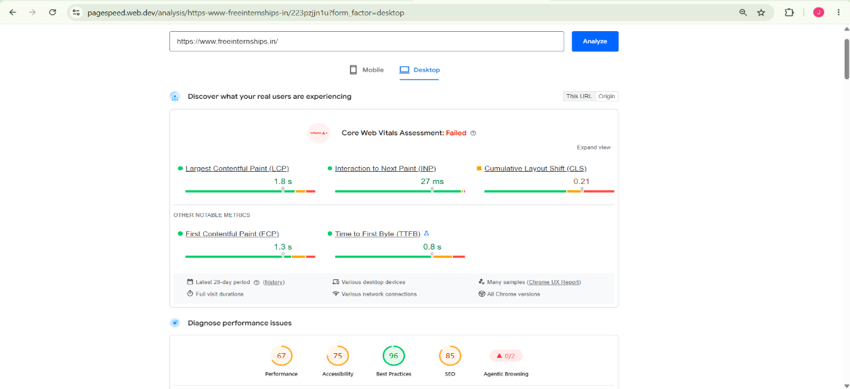
Figure 1: Desktop PageSpeed Insights Result
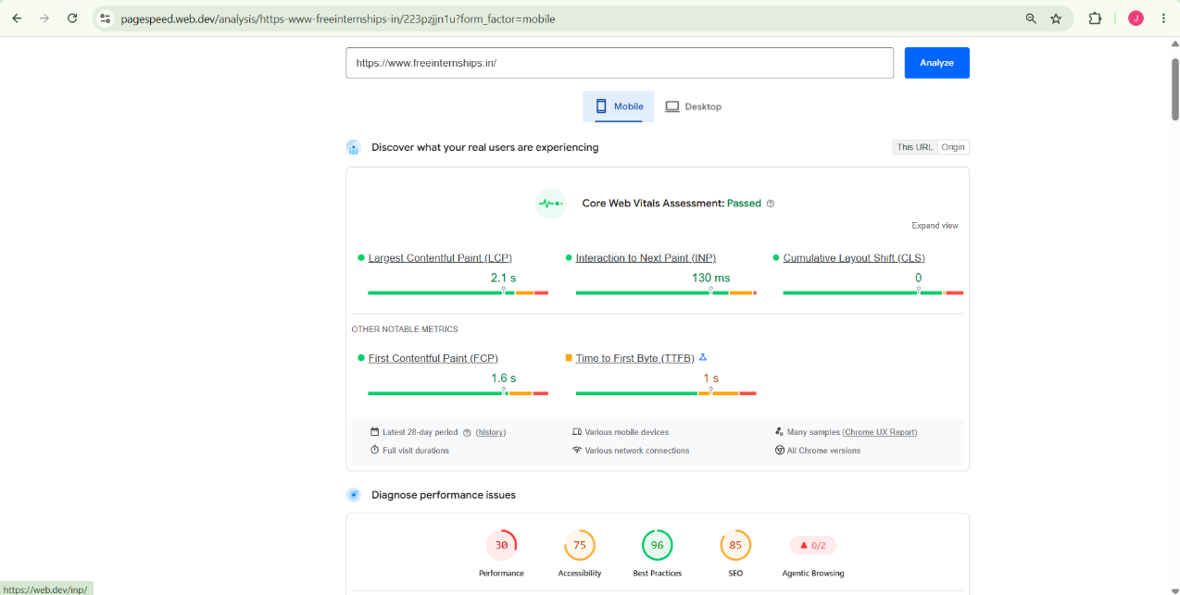
Figure 2: Mobile PageSpeed Insights Result

6. Summary
The PageSpeed analysis shows that FreeInternships.in has good Core Web Vitals on mobile, while the desktop assessment is affected by CLS. The overall mobile Performance score is relatively low and should be improved. Further technical checks such as robots.txt, XML sitemap, broken links and crawlability will be performed as part of the technical SEO audit.
Robots.txt Analysis
The robots.txt file of FreeInternships.in was checked to understand how search-engine crawlers are instructed to access the website.
The robots.txt file contains a sitemap location:
Sitemap: https://www.freeinternships.in/sitemap.xml
Finding
The website has correctly specified the XML sitemap location in the robots.txt file. This helps search-engine crawlers discover the sitemap and understand the site's available URLs.
Status
Sitemap location is specified in robots.txt.
Recommendation
No immediate action is required for the sitemap declaration. However, the XML sitemap should also be checked separately to ensure that it is accessible, updated and contains the correct canonical URLs.

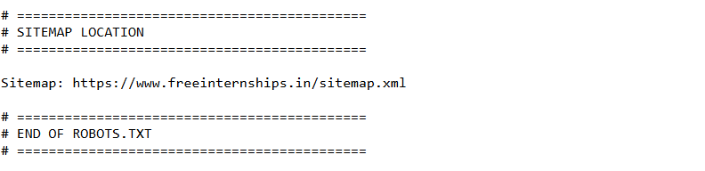
Figure 3: Robots.txt Sitemap Declaration

XML Sitemap Analysis
The XML sitemap of FreeInternships.in was checked to determine whether the website provides a structured list of URLs for search-engine crawlers.
Sitemap URL:
https://www.freeinternships.in/sitemap.xml
Findings
The XML sitemap is accessible and follows the standard XML sitemap structure. It contains website URLs using the <loc> element. The sitemap also provides <lastmod> dates and <priority> values for the listed URLs.
The sitemap includes important website pages as well as internship pages organized according to different categories and internship durations.
Status
XML Sitemap Found and Accessible
Recommendation
The XML sitemap should be regularly updated whenever important pages are added, removed or changed. It should contain only important, indexable, canonical URLs and should be submitted through Google Search Console.
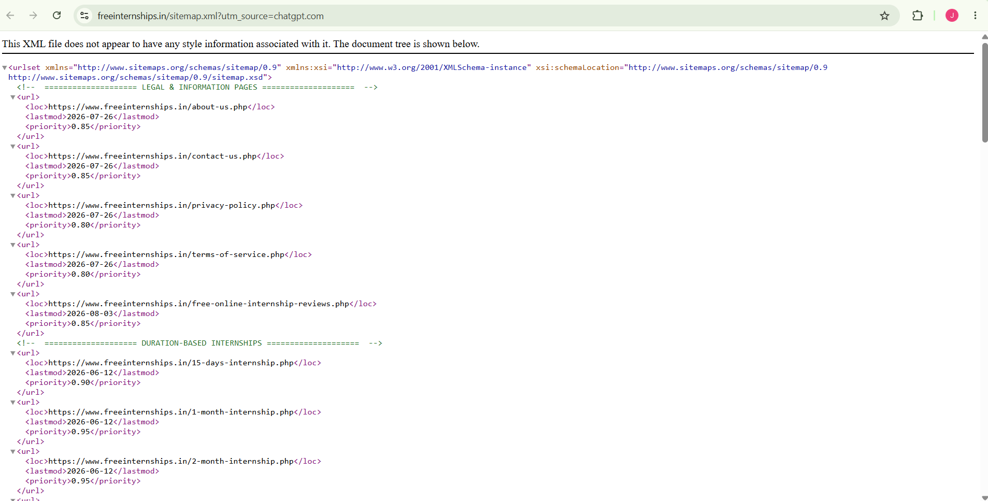
Figure 4: XML Sitemap
Broken Link Analysis
The website was checked using an online Broken Link Checker to identify dead or inaccessible hyperlinks.
The scan was terminated by the user after processing 671 web pages. During the partial scan, 4 broken links were identified. All four reported links returned a 404 (Not Found) server response.
Findings
- /student/profile.php – 404
- /student/certificate_request.php – 404
- /internship-reviews-gallery.php – 404
- /verify – 404

Recommendation
The identified broken links should be investigated and fixed. Where the intended page exists at a different URL, the link should be updated. If a page has been permanently removed and has a suitable replacement, a relevant redirect can be considered. Broken links should be removed or corrected to improve user experience and website crawlability.
Important: Since the scan was stopped after 671 pages, these results should be described as broken links found during a partial scan, not as a complete site-wide count.

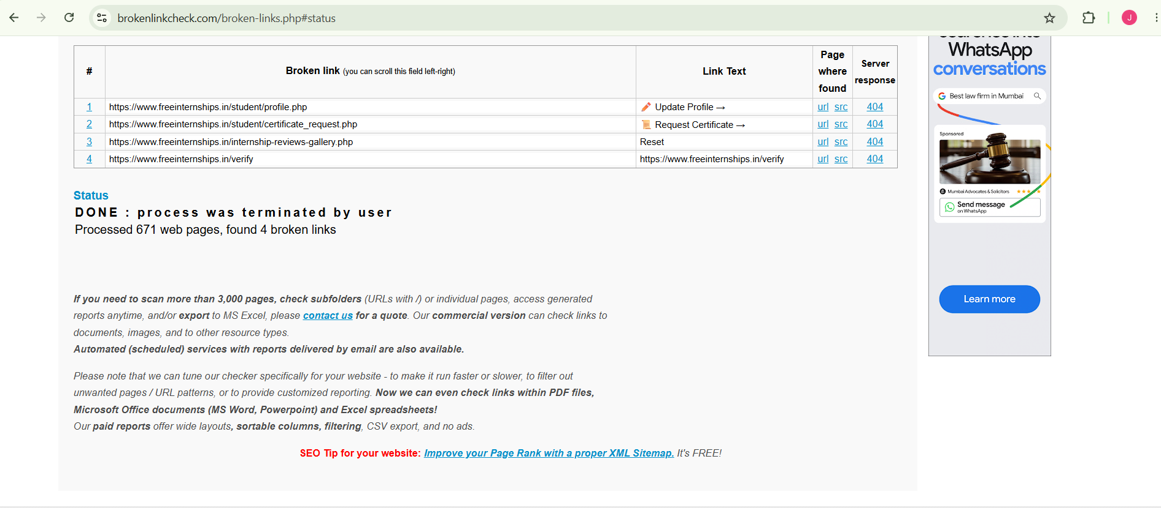
Figure 5: Broken Link Checker Results

Day 3 -Homepage Title Tag and Meta Description Analysis

The homepage source code of FreeInternships.in was reviewed to analyze the title tag and meta description.
Title Tag
Current Title:
Free Internship online with Certificate & Job Assistance | Real-Time Project Based Online Internship in India | Work From Home
Finding:
The title tag contains relevant keywords such as Free Internship, Certificate, Job Assistance, Real-Time Project, Online Internship, India, and Work From Home. However, the title is relatively long and contains multiple phrases, which may make it less concise in search results.
Recommendation:
Create a shorter and more focused title while keeping the primary keyword near the beginning.
Suggested Title:
Free Online Internships with Certificate & Real Projects | FreeInternships.in

Meta Description
Current Meta Description:
Free internship 2026 - online internship with certificate, 1-6 months, real-time projects, official certificate & job placement. Best free internship for students in India. Python, AI, Data Science, Free Digital Marketing internship
Finding:
The meta description clearly explains the website's services and includes several relevant keywords. It mentions certificates, internship duration, real-time projects, job placement, and different internship fields. However, it could be made more concise and focused.
Recommendation:
Use a clear, attractive description that explains the main benefit of the website and encourages students to visit.
Suggested Meta Description:
Join free online internships with real-world projects, certificates and practical work experience. Build your skills with internships in AI, Python, Data Science and Digital Marketing.
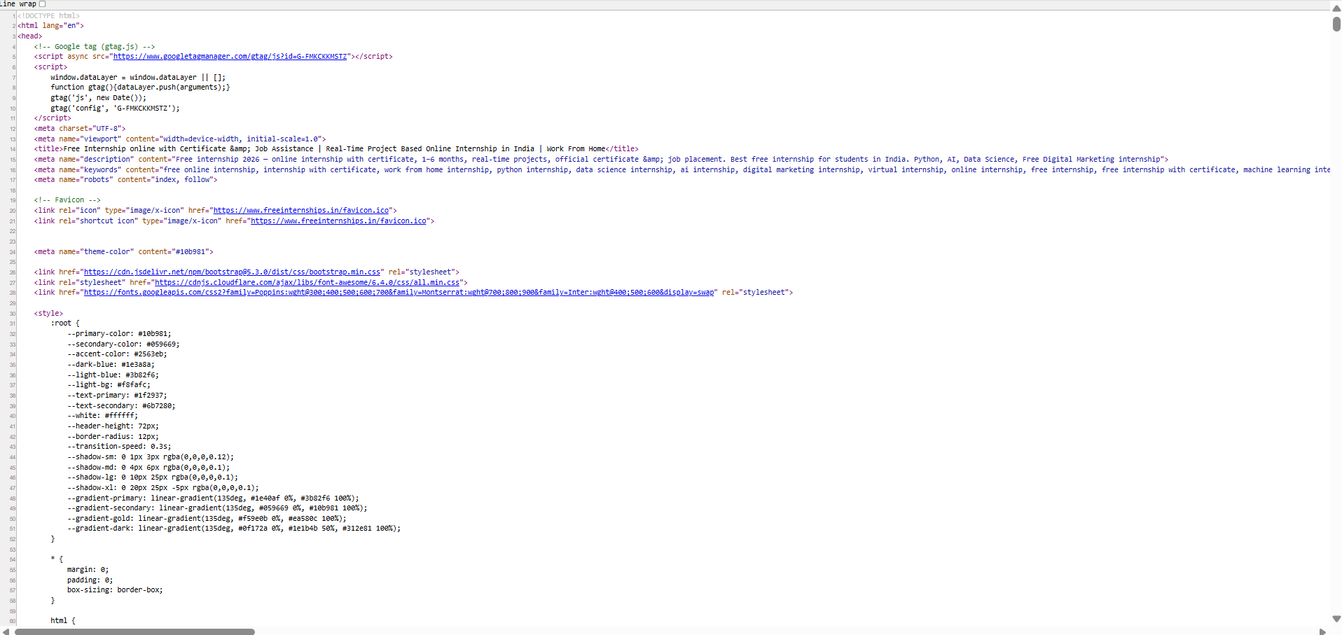

Figure 1: Homepage Title Tag and Meta Description

Heading Structure Analysis
The homepage heading structure was reviewed by examining the HTML source code.
Heading | Example | Observation
H1 | Launch Your Career with a Free Online Internship & Get Certified in 2026 | Clear and relevant main heading
H2 | What is Free Internship Online at freeinternships.in? | Used for major content sections
H3 | Explore Our Internship Programs | Used for the internship programs section
H3 | Digital Marketing -Free | Used for individual internship programs
H3 | Graphics Design-Free | Used for individual internship programs

Finding:
The homepage uses a logical heading hierarchy with a clear H1 followed by H2 and H3 headings. The headings are relevant to the website's content and include important SEO keywords.
Recommendation:
Maintain a logical H1 → H2 → H3 hierarchy throughout the website. Avoid skipping heading levels unnecessarily and ensure that headings accurately describe the content that follows them.
Content Quality and Keyword Usage Analysis
The homepage content was reviewed to evaluate its relevance, usefulness, readability, and keyword usage.
Finding:
The homepage provides clear information about the internship opportunities offered by the website. It highlights important benefits such as free online internships, certificates, real-time projects, job assistance, and work-from-home opportunities. It also mentions internship areas such as AI, Data Science, Python, Machine Learning, and Digital Marketing.
The primary keyword “Free Online Internship” is prominently used in the main heading and supporting content. Other relevant keywords are also included naturally throughout the homepage.
Strengths:
- Content is relevant to students and freshers.
- Main services and benefits are clearly explained.
- Important internship-related keywords are present.
- Different internship domains are mentioned.
- Calls-to-action such as “Apply for Internship” are clearly visible.
Recommendations:
- Keep the content simple, useful, and easy to read.
- Avoid excessive repetition of the same keywords.
- Add more detailed, original information about each internship program.
- Include student FAQs to target additional long-tail search queries.
- Keep important keywords natural rather than forcing them into every section.
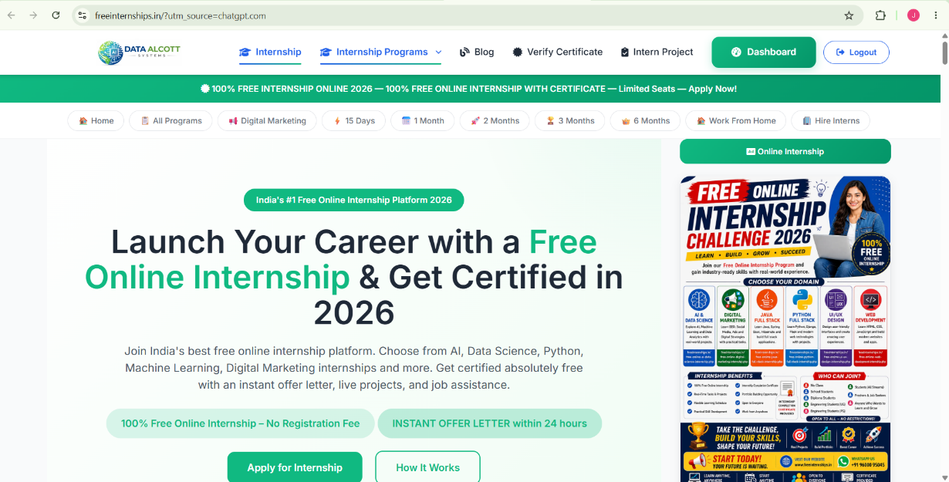
Figure: Homepage Content and Keyword Usage

Image Optimization and ALT Tag Analysis
The homepage HTML source was reviewed to check whether images contain descriptive ALT attributes.
Finding:
The reviewed images contain meaningful and descriptive ALT text. For example, the certificate images use ALT descriptions explaining that they are official internship certificates.
Strengths:
- ALT attributes are present for the reviewed images.
- ALT text describes the purpose/content of the images.
- Descriptive ALT text can support image accessibility and search engine understanding.
Recommendation:
Ensure that all important images across the website have unique, descriptive ALT text. Avoid keyword stuffing and avoid using generic ALT text such as “image” or “picture”.

Overall On-Page SEO Summary
The homepage of FreeInternships.in was analyzed for important on-page SEO factors, including the title tag, meta description, heading structure, content quality, keyword usage, and image ALT tags.
Overall, the homepage has a good on-page SEO foundation. The primary topic of free online internships is clearly communicated, relevant keywords are used, and the page contains a structured heading hierarchy.
SEO Factor | Finding | Status
Title Tag | Relevant keywords are included, but the title is lengthy | Needs Improvement
Meta Description | Informative and keyword-relevant | Good
H1 Heading | Clear and relevant H1 is present | Good
H2/H3 Structure | Logical heading hierarchy is used | Good
Content Quality | Useful information about internships and benefits | Good
Keyword Usage | Relevant keywords are used throughout the content | Good
Image ALT Tags | Descriptive ALT text found for reviewed images | Good

Key Recommendations
1. Optimize the Title Tag
Make the homepage title shorter and more focused while keeping the primary keyword “Free Online Internship.”
Suggested Title:
Free Online Internships with Certificate & Real Projects | FreeInternships.in
2. Improve the Meta Description
Keep the description concise, attractive, and focused on the main benefits of the website.
3. Maintain Heading Hierarchy
Continue using a logical:
H1 → H2 → H3
structure throughout the homepage and other important pages.
4. Improve Content
Add more useful and original content about:
- Internship programs
- Eligibility
- Application process
- Skills students can gain
- Certificate details
- Frequently Asked Questions (FAQs)
5. Use Keywords Naturally
Continue using relevant keywords such as:
- Free Online Internship
- Online Internship with Certificate
- Internship for Students
- Work From Home Internship
- Real-Time Projects
Avoid excessive repetition or keyword stuffing.
6. Optimize Images
Ensure that all important images have unique and descriptive ALT text. Also optimize image file sizes to improve page loading speed.

Conclusion
Overall On-Page SEO Status: Good, with some areas for improvement.
The homepage has a strong basic on-page SEO structure with a relevant H1, organized H2/H3 headings, useful content, relevant keywords, and descriptive ALT text for the reviewed images. The main areas requiring improvement are title length, content expansion, and continued image optimization.
Day 4 - Backlink Analysis
The backlink profile of FreeInternships.in was analyzed using Ahrefs Backlink Checker.
Metric | Result
Domain Rating | 7
Backlinks | 691
Linking Websites | 118
Dofollow Backlinks | 87%
Dofollow Linking Websites | 23%

Findings
The website has 691 backlinks from 118 linking websites. The Domain Rating is 7, which indicates that the website has a relatively low level of domain authority compared with established websites.
A high percentage (87%) of the reported backlinks are dofollow, which can potentially contribute to the site's authority when they come from relevant and trustworthy websites.
Recommendations
- Build backlinks from high-quality and relevant education/internship websites.
- Promote useful internship-related content to earn natural backlinks.
- Consider guest posting on relevant educational and career websites.
- Create useful resources, guides, and internship-related articles that other websites may want to reference.
- Avoid low-quality or spammy backlinks.
- Focus on increasing the number of high-quality referring domains, rather than only increasing the total backlink count.

Domain Authority (DA) Analysis
The Domain Authority of freeinternships.in was checked using a Moz-based Domain Authority Checker.
Results:
- Domain Authority (DA): 10/100
- MozRank: 0.40/10
- Linking Domains: 45
- Inbound Links: 47
- Spam Score: -1%
Analysis:
The website has a relatively low Domain Authority score of 10, indicating that its overall website authority and backlink strength can be improved. The website has 45 linking domains and 47 inbound links according to this checker.
Recommendations:
- Build backlinks from high-quality and relevant education websites.
- Get backlinks from universities, colleges, student communities and internship-related websites.
- Create useful, shareable content to naturally attract backlinks.
- Focus on quality and relevant backlinks rather than only increasing the number of backlinks.
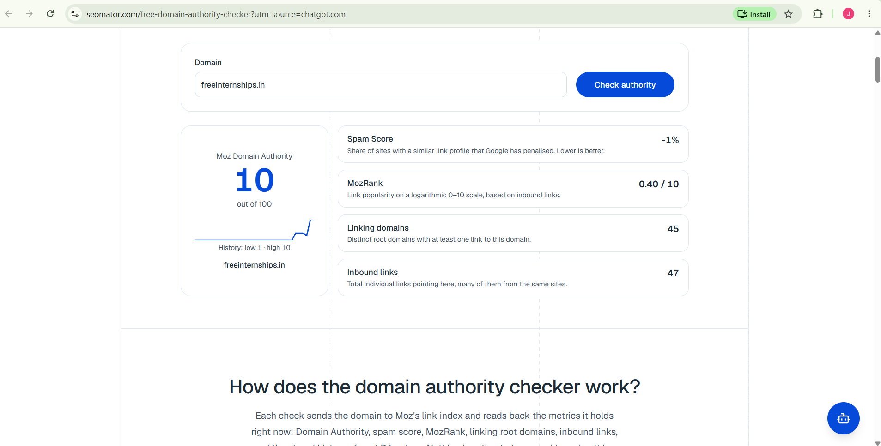

Social Media Presence Analysis
The website was checked for social media presence. The Contact Us page provides links to the following social media platforms:
- LinkedIn – Data Alcott Systems
- YouTube – @freeinternshipsonline
Analysis:
The presence of LinkedIn and YouTube provides opportunities to build brand awareness, engage with students, share internship opportunities, and increase website visibility.
Recommendations:
- Add social media links/icons to the main website footer for easier access.
- Maintain regular activity on LinkedIn and YouTube.
- Share internship updates, student achievements, certificates, projects and career-related content.
- Encourage students to follow and share the social media pages.
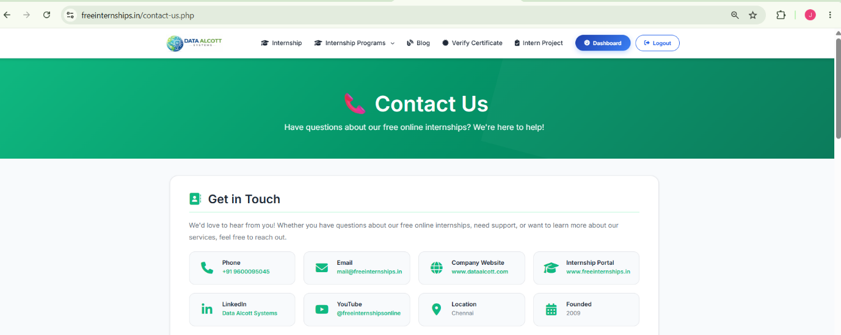

Brand Mentions Analysis
The online presence of FreeInternships.in was checked to identify brand mentions on external websites and platforms.
Findings:
- FreeInternships.in is mentioned on LinkedIn through Data Alcott Systems.
- A separate Free Internships Online LinkedIn presence also references the website.
- The website itself publishes internship-related content and project submissions, which helps strengthen its online brand presence.
Analysis:
The website has some external brand presence, particularly on LinkedIn. However, increasing mentions from relevant educational websites, student communities, colleges and career platforms could further improve brand awareness and authority.
Recommendations:
- Build more mentions on education and career websites.
- Encourage students and interns to share their internship experiences.
- Publish useful career and internship content that other websites can reference.
- Increase LinkedIn activity and engagement.
- Seek relevant partnerships with colleges and educational communities.

Day 5 - Competitor Analysis
Competitor 1: AICTE National Internship Portal
Strengths:
- Large number of internship opportunities.
- Strong credibility through Government of India and AICTE association.
- Provides verified internship listings.
- Offers remote, hybrid and onsite opportunities.
- Provides filtering options based on category and work mode.
- Includes both technical and non-technical internships.
- Many opportunities provide stipends.
Weaknesses:
- The large number of listings may make it difficult for students to identify the most suitable internship quickly.
- The platform focuses mainly on internship listings and applications rather than providing a completely free project-based learning experience.
Comparison with FreeInternships.in:
FreeInternships.in focuses strongly on free online internships, practical projects, certificates and skill development, while the AICTE portal provides a much larger marketplace of internship opportunities from different organizations.
Opportunity for FreeInternships.in:
FreeInternships.in can differentiate itself by providing simple student-focused navigation, practical project-based internships, certificates, career guidance and easy access to free programs.
Overall Competitor Strength: High ⭐⭐⭐⭐
Competitor 2: Skill India Digital Hub
Strengths:
- Government of India / Ministry of Skill Development and Entrepreneurship platform.
- Provides dedicated internship listings.
- Offers both Paid and Free internships.
- Provides filters for:
  - Internship Provider
  - Internship Fee
  - Mode of Internship
  - Internship Duration
  - Educational Qualification
  - Sector
- Includes internships in areas such as Python, Marketing, Inventory Management, etc.
Weaknesses:
- Many internship opportunities shown are paid.
- Students may need to compare different providers and programs to find the right opportunity.
- The platform covers many skill-development services, so it is broader than a dedicated free-internship platform.
Comparison with FreeInternships.in:
Skill India Digital Hub has strong government credibility and provides structured filters and multiple internship providers. FreeInternships.in has a stronger focus on free internships, practical projects, certificates and student-focused internship programs.
Opportunity for FreeInternships.in:
FreeInternships.in can compete by emphasizing 100% free internships, practical project experience, certificates, simple navigation and student-focused content.
Overall Competitor Strength: High ⭐⭐⭐⭐
Competitor 3: Upskill Campus
Strengths:
- Focuses on career support and internship opportunities.
- Provides Certificate of Completion.
- Provides Offer Letter.
- Offers real-world, hands-on projects.
- Provides doubt-clearing sessions and expert guidance.
- Provides networking opportunities with industry professionals.
- Offers flexible learning and practical skill development.
- The screenshot shows strong registration numbers across previous internship seasons.
Weaknesses:
- The platform covers internships as well as courses and other career-support services, so it is broader than a dedicated free-internship platform.
- Its internship benefits and structure may vary depending on the program.
Comparison with FreeInternships.in:
Upskill Campus provides several features similar to FreeInternships.in, including certificates, offer letters, practical projects and career development. FreeInternships.in can differentiate itself by emphasizing its free internship programs and simple student-focused experience.
Opportunity for FreeInternships.in:
- Highlight the 100% free nature of the internships.
- Promote real-time projects and certificates.
- Publish student success stories and project outcomes.
- Improve visibility through career-focused content and social media.
Overall Competitor Strength: High ⭐⭐⭐⭐
Competitor 4: Thiranex
Strengths:
- Offers 100% free virtual internships.
- Provides internships across 15+ domains.
- Provides an instant offer letter.
- Internships involve real-world projects and task submissions.
- Offers flexible, self-paced learning.
- Provides certificate verification.
- Targets students and recent graduates across India.
- Promotes internship opportunities in areas such as Python, Data Science, AI & Machine Learning, Cyber Security, UI/UX and Digital Marketing.
Weaknesses:
- The platform has strong overlap with FreeInternships.in because both focus on free virtual internships, projects and certificates.
- The internship platform needs to maintain clear differentiation from other free-internship providers.
- Some internship-related pages currently depend on dynamic content, and the internships page showed a temporary failure to load listings during the website check.
Comparison with FreeInternships.in:
Thiranex is a direct competitor because it also offers free virtual internships, real-world projects, offer letters and certificates. FreeInternships.in can differentiate itself through stronger content quality, better SEO, detailed internship information, student success stories and a smooth user experience.
Opportunity for FreeInternships.in:
- Create detailed pages for each internship domain.
- Publish student success stories and project examples.
- Improve SEO for keywords such as free online internship, internship with certificate and virtual internship for students.
- Strengthen social media promotion.
- Build high-quality backlinks from colleges and educational websites.
Overall Competitor Strength: High ⭐⭐⭐⭐⭐
Keyword Gap Analysis
FreeInternships.in already targets important terms such as “free online internship,” “internship with certificate,” “work from home internship,” “Python internship,” “Data Science internship,” “AI internship,” “Digital Marketing internship,” “virtual internship,” and “internship for students.”
The competitors also target overlapping terms such as free internship, virtual internship, remote internship, engineering internships, Python, Data Science, AI/ML, Digital Marketing, certificates, and career development.

Screenshots & Evidence
Day 1 - Research & Planning

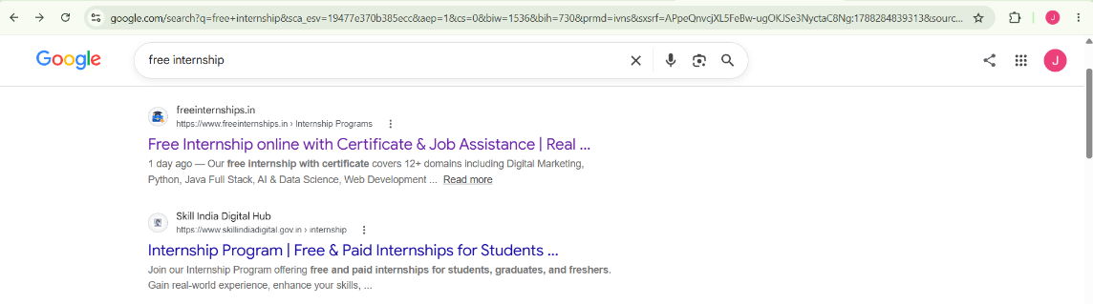
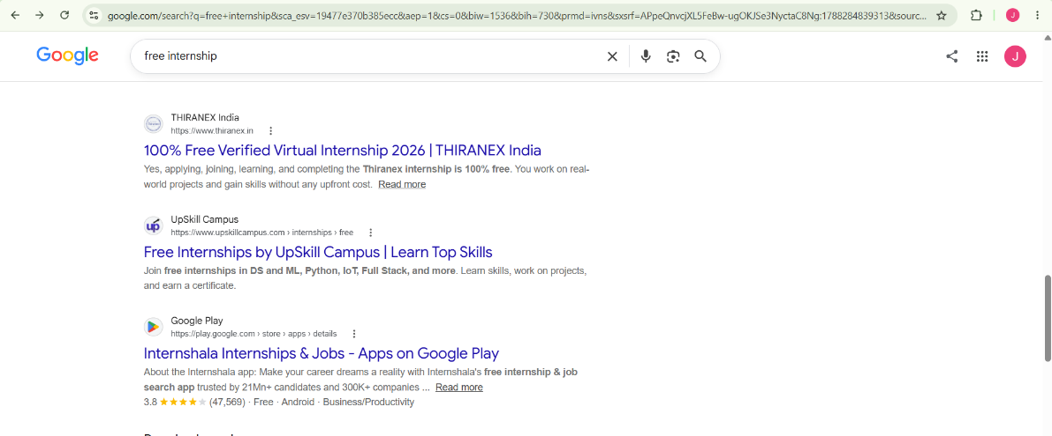

Figure 1: Google Search – Free Internship
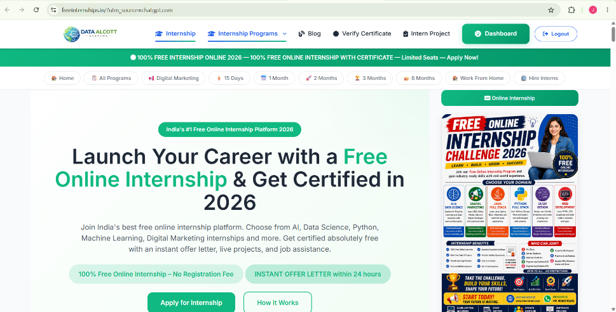

Figure 2: FreeInternships.in Homepage

Day 2 – Technical SEO

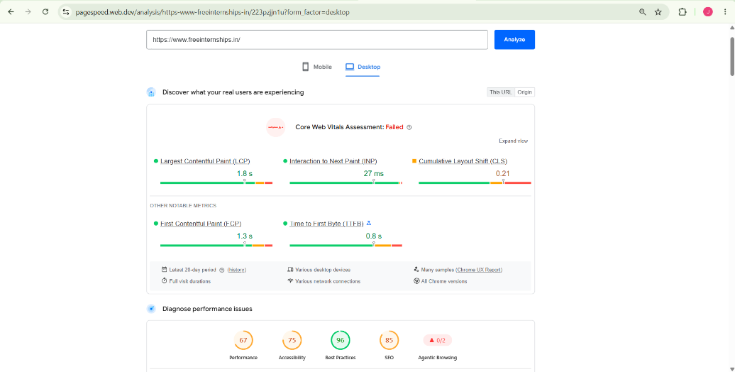

Figure 3: Desktop PageSpeed Insights
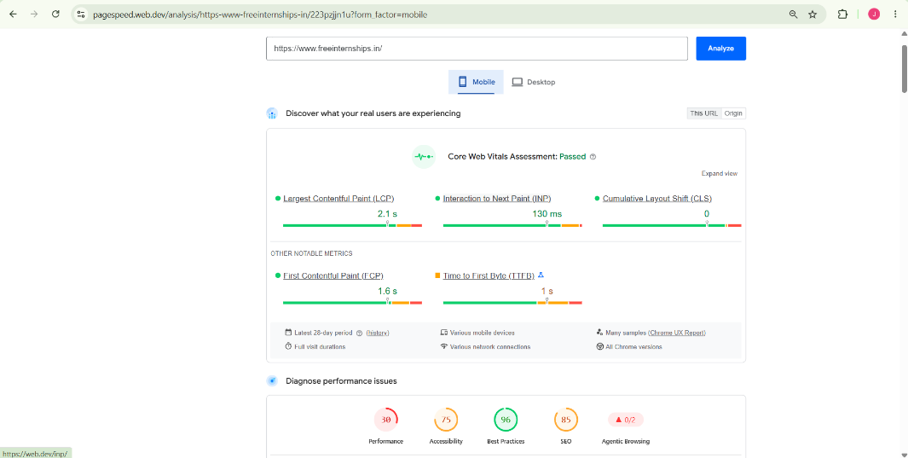

Figure 4: Mobile PageSpeed Insights

Figure 5: Robots.txt

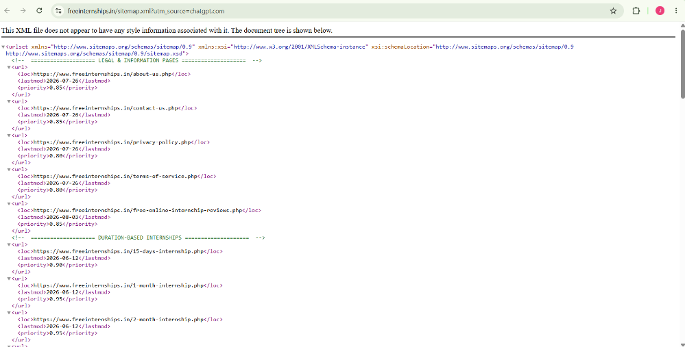
Figure 6: XML Sitemap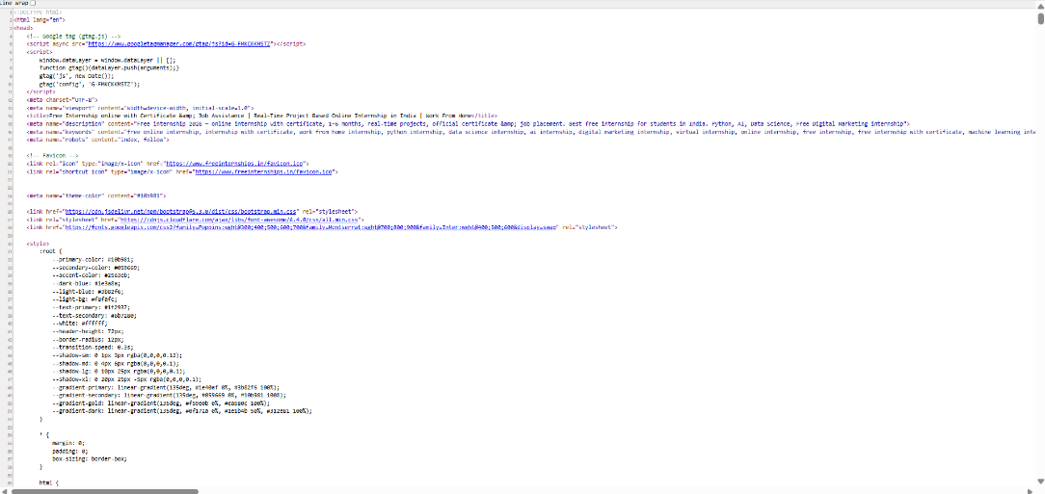
Figure 7: Broken Link Checker
Day 3 – On-Page SEO
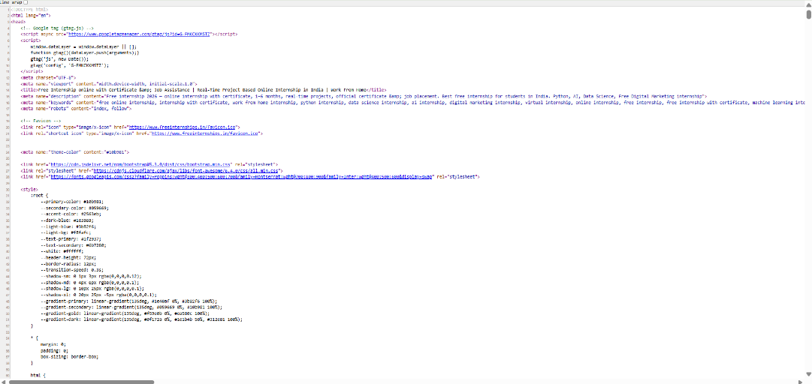
Figure 8: Homepage Title Tag and Meta Description
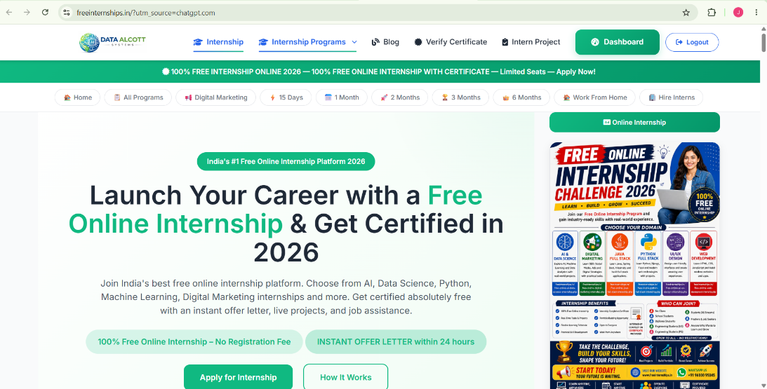
Figure 9: Homepage Content and Keyword Usage

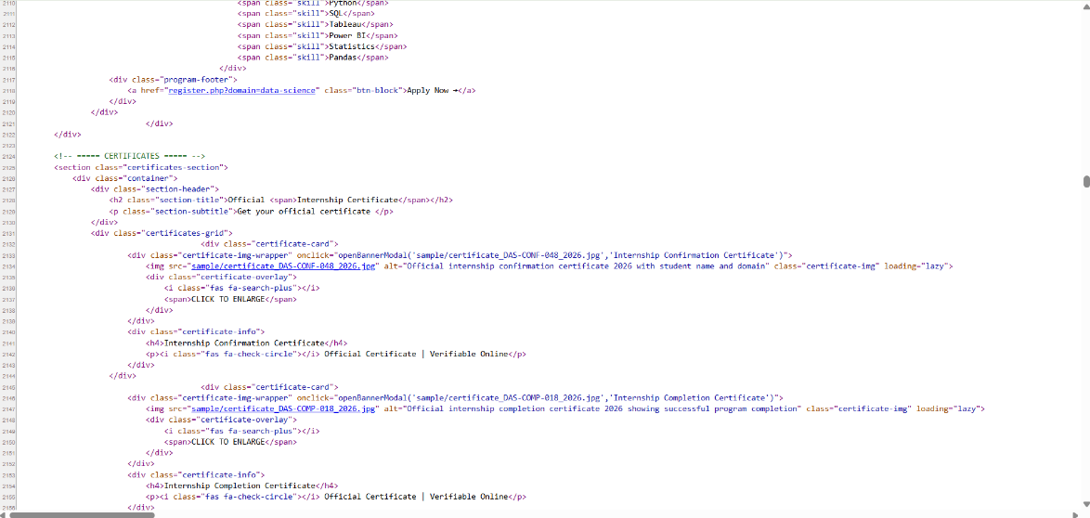
Figure 10: Image ALT Tags
Day 4 – Off-Page SEO
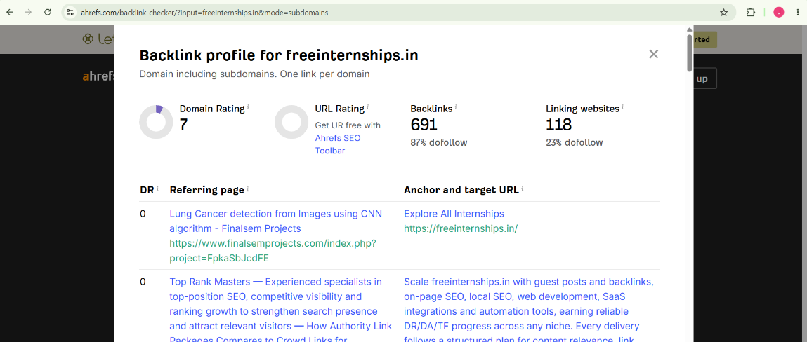

Figure 11: Ahrefs Backlink Analysis
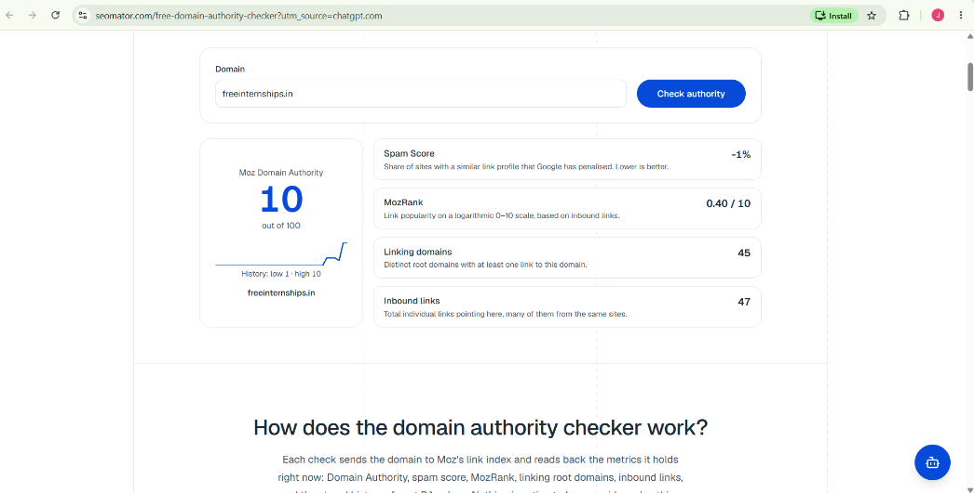
Figure 12: Domain Authority Analysis

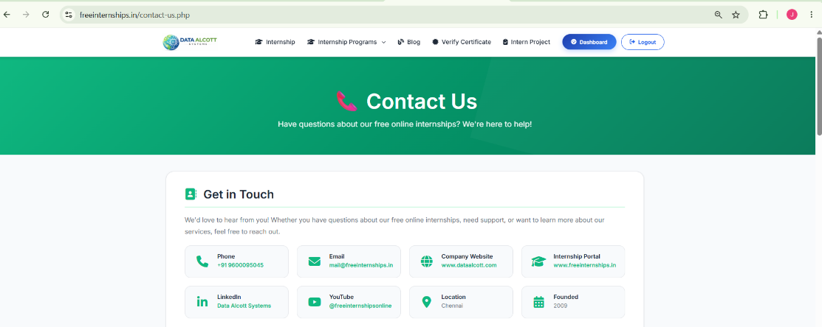
Figure 13: Social Media Presence
Day 5 – Competitor Analysis
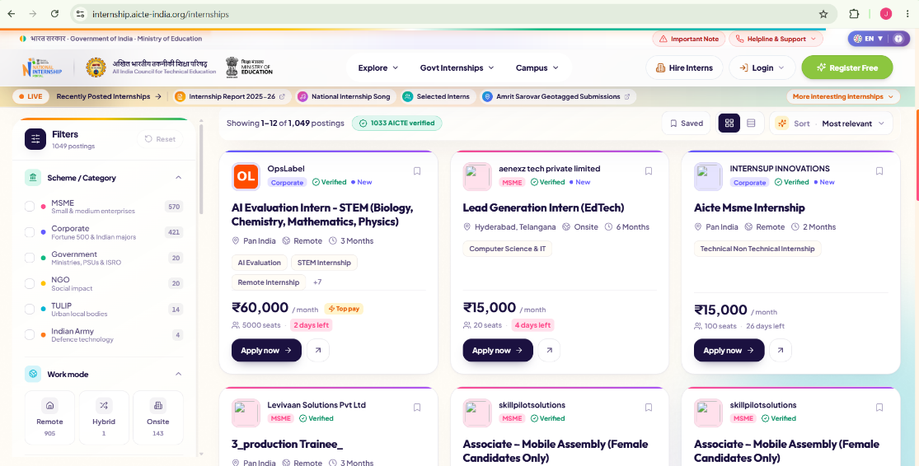
Figure 14: AICTE National Internship Portal

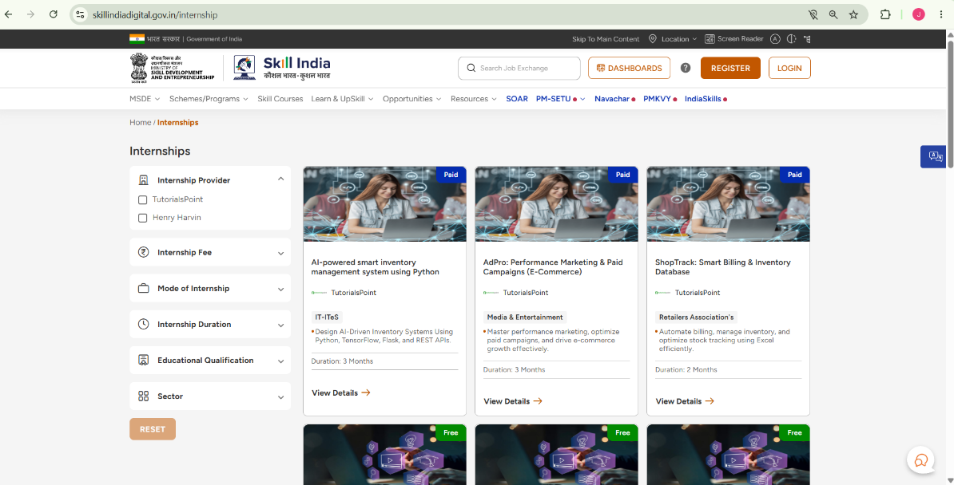
Figure 15: Skill India Digital Hub
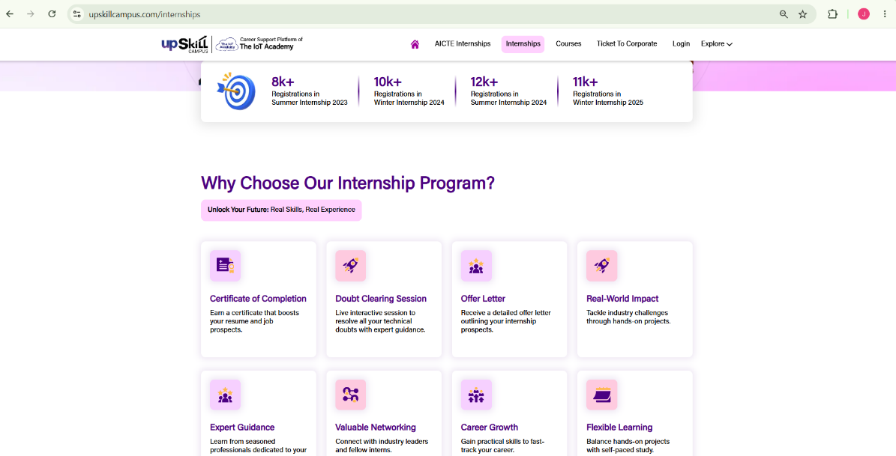
Figure 18: Upskill Campus

